Department of English E-content

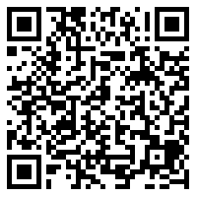

https://pgdepartmentofenglishgacnandanam.blogspot.com/2020/12/blog-post_17.html?m=1

